Q1. Find out the mail servers of the following domain:

Ibm.com

Wipro.com

Ans : Through **nslookup** cmd we find out the mail servers of any domain.

First we go to cmd prompt in windows os and type nslookup afterthat write the domain name to find out the ip address. Now to find out the mail server of particular domain type **“set type=mx**” then enter then type domain name then we will find out the name of mail server of a particular domain.

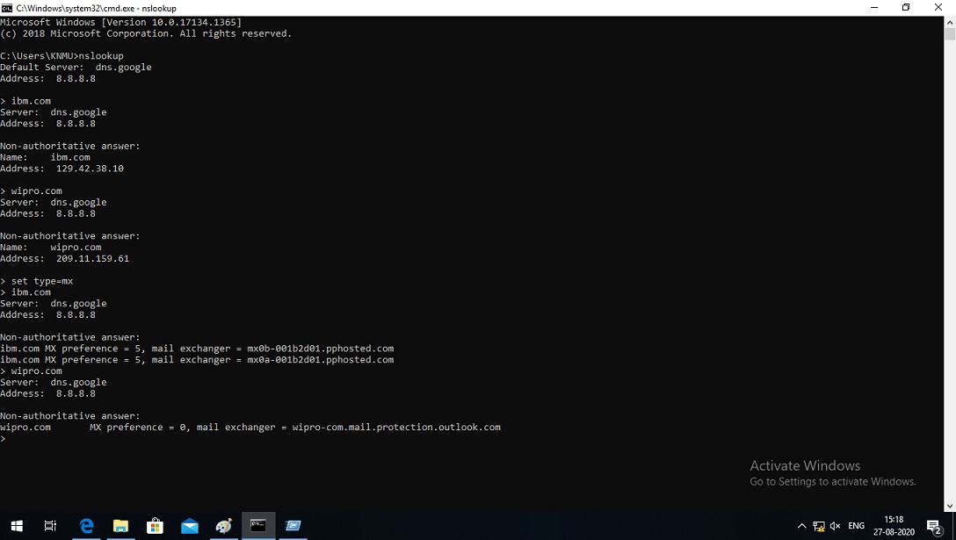

Q2. Find the locations, where these email servers are hosted.

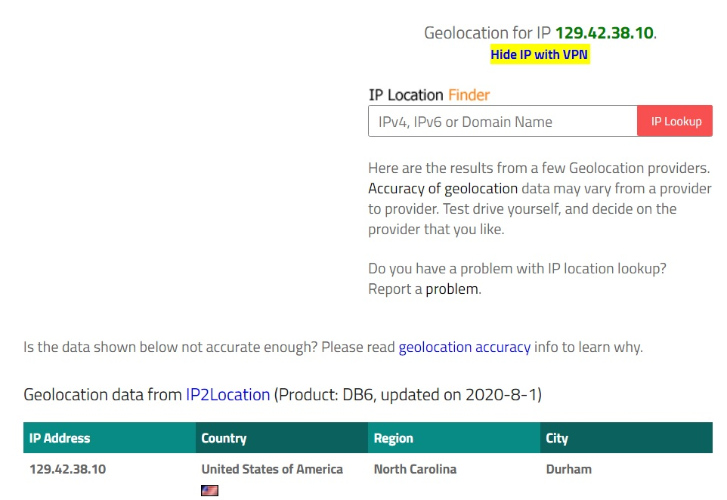Ans. To find out the locations first we get the ip address of the particular domain through **nslookup** cmd.

After that go to internet explorer type [**www.iplocation.net**](http://www.iplocation.net)type ip address on ip location finder .

* Click on ip lookup. Then below our result is shown.

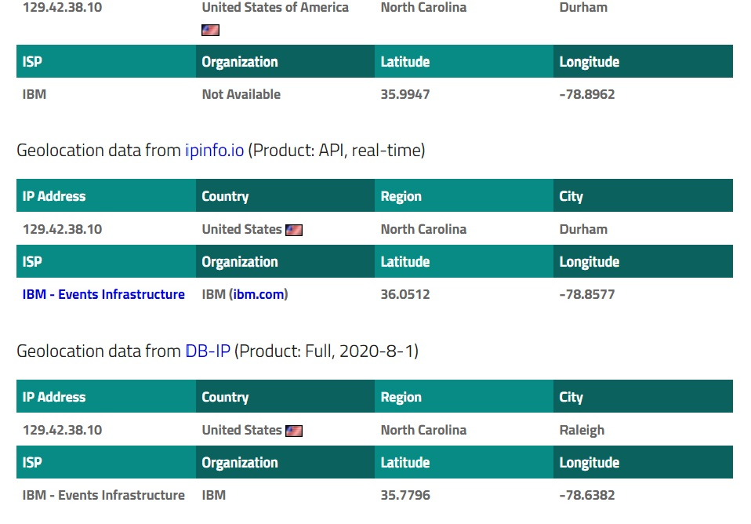

2**. Location of wipro.com is given below**

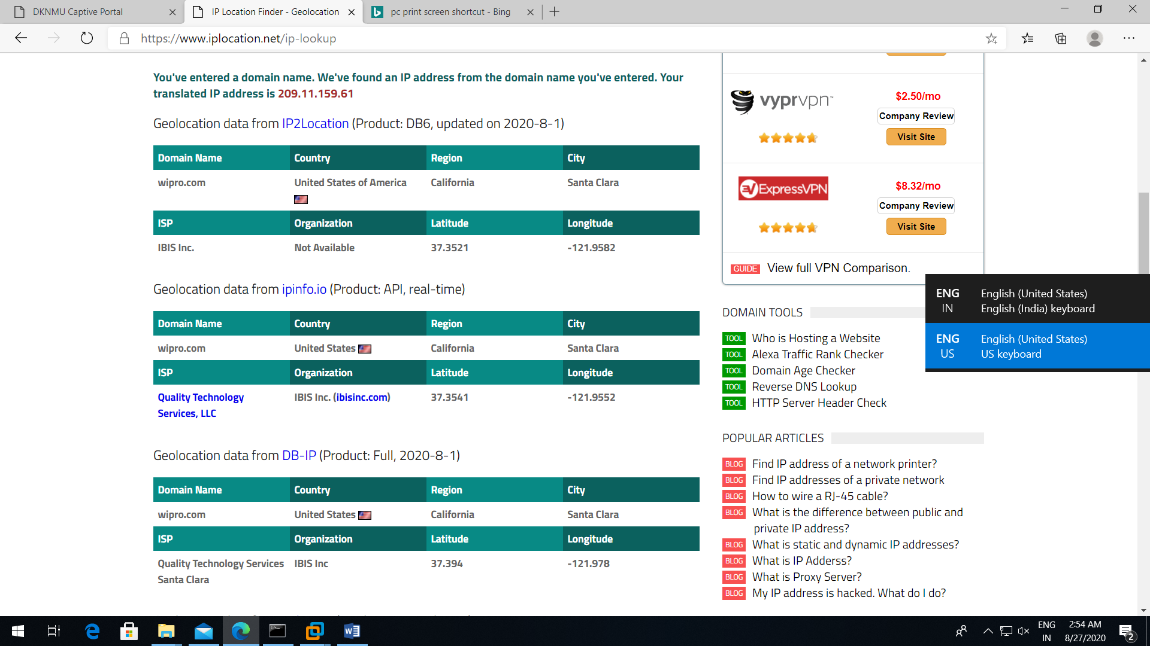

Q3. Scan and find out port numbers open 203.163.246.23.

Ans: Through nmap cmd we find out the port is open or closed of any network.

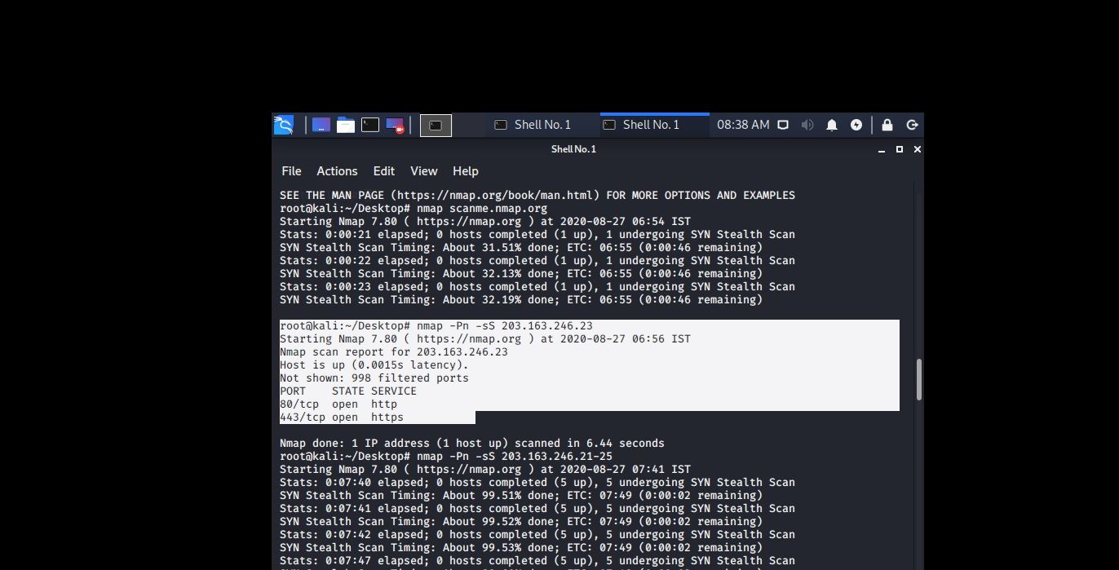

Through nmap -Pn -sS 203.163.246.23 we find out port open or close.

So that shows port no 80 for http and port no 443 for https is open in that case.

Q4. Install nessus in a VM and scan your laptop/desktop for CVE.

Ans. First I install vm and in it I install nessus . Here is the image.

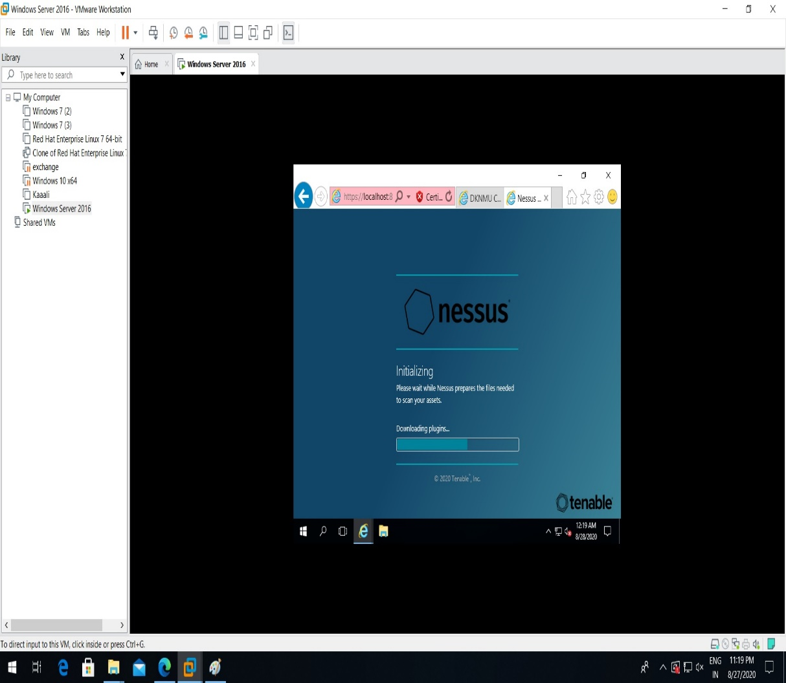

After completing the installation of nessus this console is open.

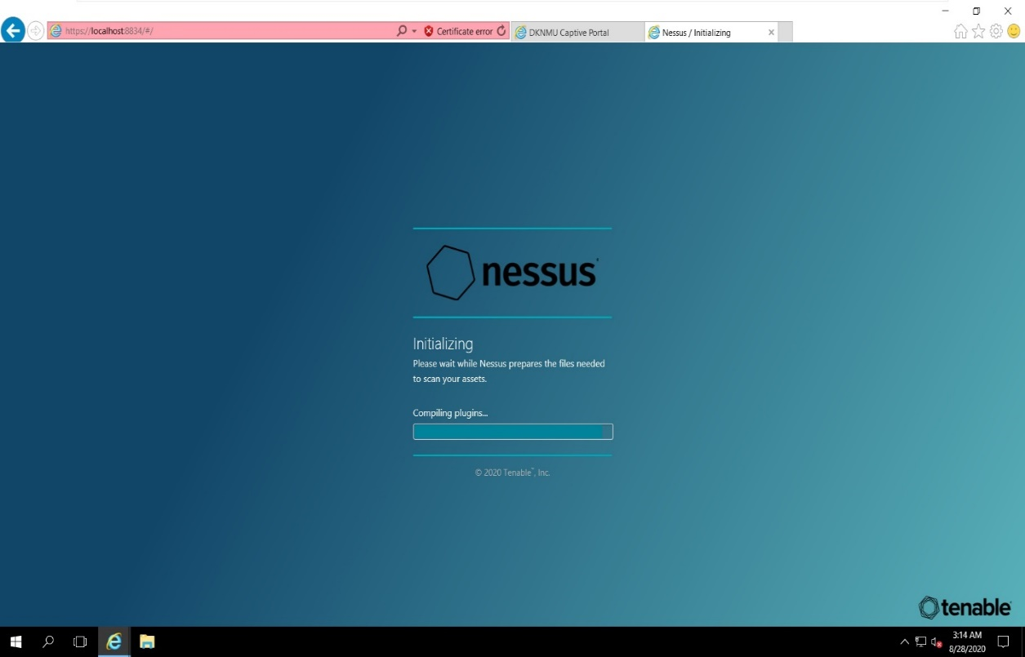

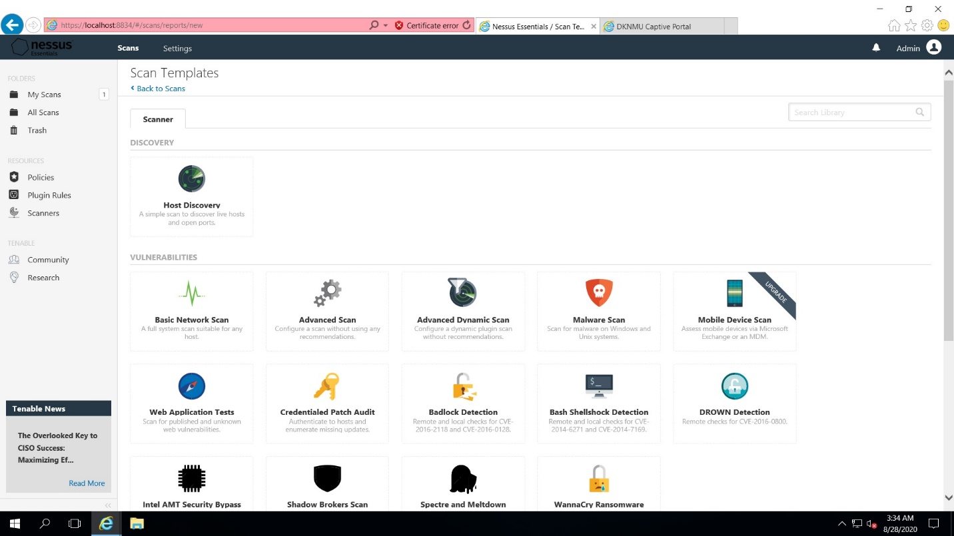

After that click on **advance scan** now below console is open**.**

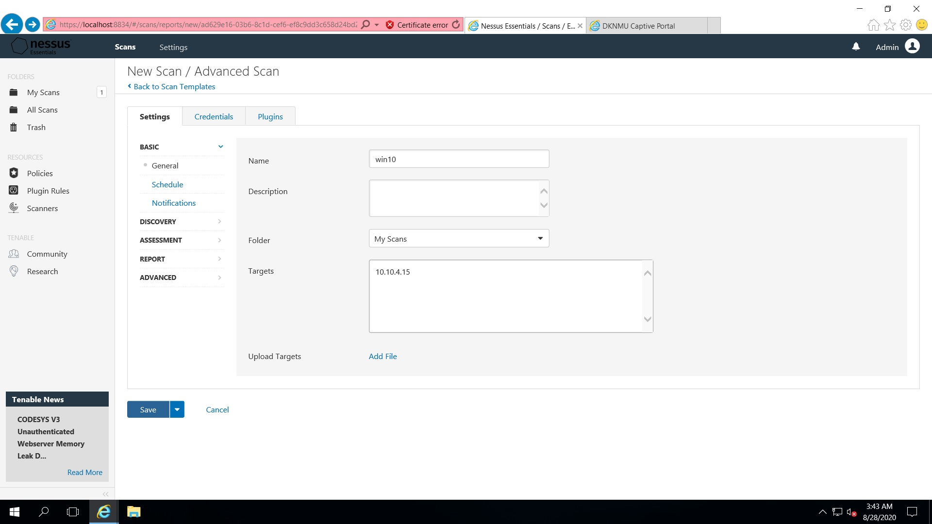

Now type the name of the machine. Description is not required put the ip address of the target like we put our base machine win 10 ip add which is 10.10.4.15. and click on save button.

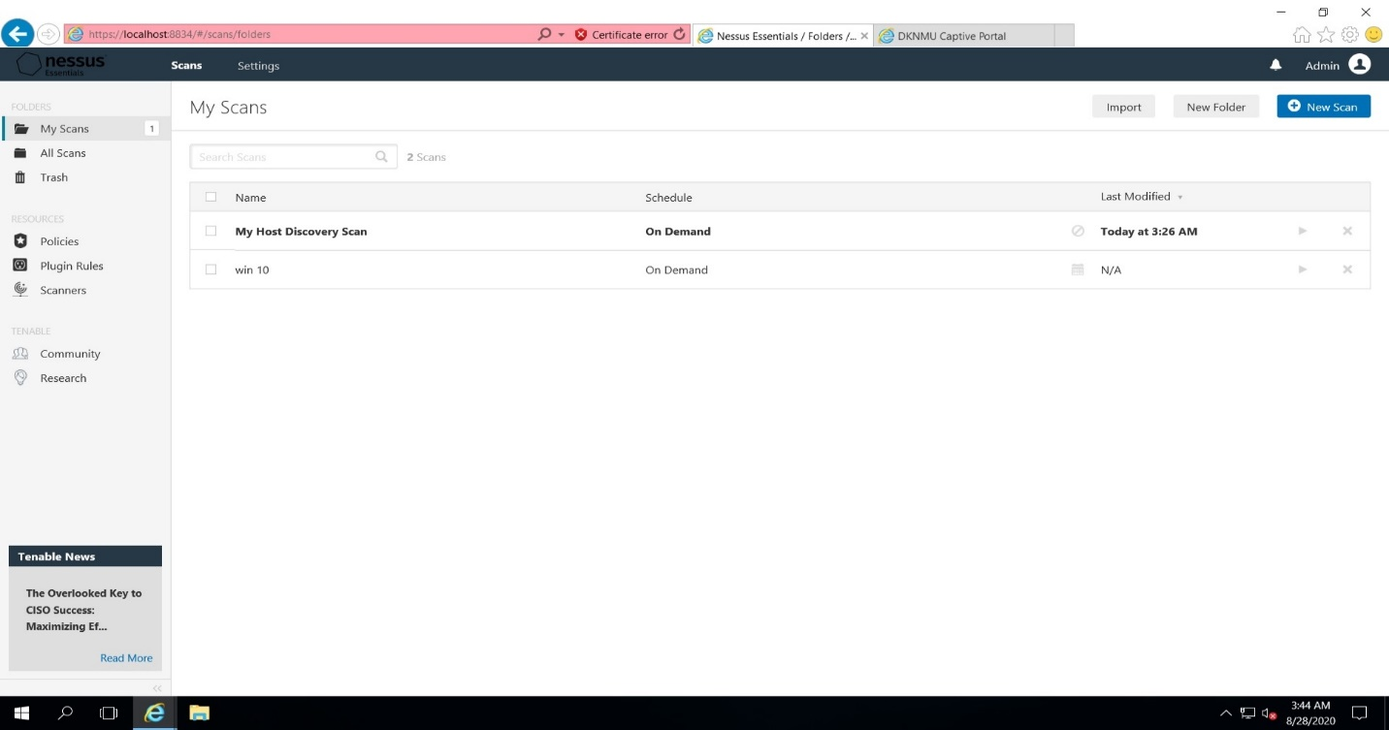This console is open then click on play button then it will scan the pc.

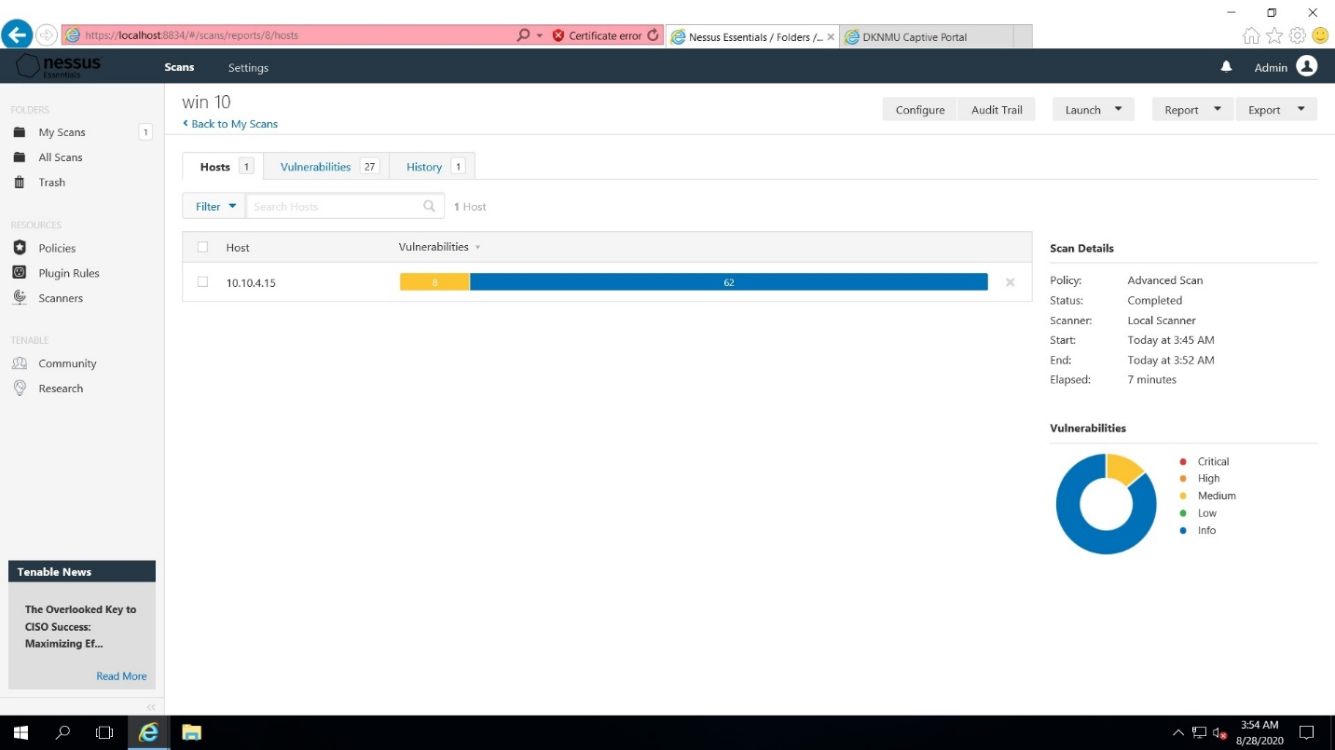The above image shows the vulnerability of my desktop